

|  |  |  |  |
| --- | --- | --- | --- |
| Student Name: | Shane Kelly  Johan Goh  Garreth Mulleady  Guan Xian Chua | | |
| Student Number: | G00391249  G00388771  G00383262  G00397303 | | |
| Programme: | Business Information Systems | | |
| Year: | 2 | | |
| Module: | Project Management | Module Code: | 2122 |
| Lecturer | John Kennedy | | |
| Assignment Title: | Implementing Technology into an SME | | |
| Number of Pages: | 48 | | |
| Due Date: | 19th November 2021 | | |
| Date Submitted: | 19th November 2021 | | |
| Additional Information: |  | | |
| **Plagiarism Disclaimer:**  The School of Business recognises that plagiarism is a serious academic offence and reserves the right to deal with breach of the offence appropriately.  I have read and understand the ‘School of Business Style Guide for Assignments’ and agree to the guidelines set out therein in relation to plagiarism and referencing. I confirm that the entire content of this assignment has been completed by me, and is not the work of another. I also confirm that I have properly referenced and acknowledged all sources used in preparation of this assignment. I understand that if I plagiarise, or if I knowingly assist others in plagiarising that I may receive a mark of zero and be brought before the disciplinary committee. I understand and agree that plagiarism detection software may be used on my assignment.  I declare that this is entirely my work based on my own personal study and/or research and I further declare that I have not engaged the services of another to either assist in or complete this assignment. | | | |
| Signed: | Shane Kelly  Johan Goh  Garreth Mulleady  Guan Xian Chua | | |
| Date: | 18/11/21 | | |
| **Please note:** Students MUST retain a hard/soft copy of all assignments. | | | |
| For Lecturer Use Only: |  | | |
| Mark Awarded: |  | | |
| Marked Out of: |  | | |
| Comments: |  | | |

**Project Management**

**Report**

*‘Implementing Technology*

*into a SME’*

**

By Johan Goh, Shane Kelly, Garreth Mulleady and Guan Xian Chua

|  |  |  |  |  |  |  |  |  |  |  |  |
| --- | --- | --- | --- | --- | --- | --- | --- | --- | --- | --- | --- |
| Student Name | Student Number | Intro | Description | Background | Methodology | Brainstorming | WBS | MS Project | Budget | Ref | Presentation |
| Shane Kelly | G00391249 | 20 | 15 | 60 | 15 | 25 | 20 | 30 | 30 | 20 | 25 |
| Garreth Mulleady | G00383262 | 15 | 15 | 10 | 60 | 25 | 20 | 20 | 15 | 20 | 30 |
| Johan Goh | G0038871 | 55 | 20 | 20 | 15 | 25 | 40 | 30 | 40 | 20 | 30 |
| Guan Xian Chua | G00397303 | 10 | 50 | 10 | 10 | 25 | 20 | 20 | 15 | 40 | 15 |
| All students each took a relevant section as indicated in this table above. However, as a group we collectively contributed equally to each section.  Shane: Background  Garreth: Methodology  Johan: Budget, WBS  Guan: Description, Glossary  All other sections were a group effort. | | | | | | | | | | | |

## 

## Executive Summary

**Problem Statement**

As a result of Covid-19 and Brexit, many SMEs are struggling to stay afloat in the market and economy. Many companies are being forced to digitalise many processes within the organisation in order to continue operations. Our client, Willow, is an SME which is struggling to implement technology into its business processes, as SMEs tend to not have the expertise and knowledge to do so. Hence, we were tasked to solve this issue and assist the company in integrating technology into its business model.

Willow is facing issues in carrying out its business activities due to movement and social restrictions. It has had to close its offices and limit customer interaction which has hurt the business as it functions mostly physically. Implementing technology into Willow will help it stay competitive as it becomes more efficient by lowering costs, increasing productivity, and making processes more seamless.

**Solution**

Upon researching many SMES which have successfully implemented technologies into their business models, we have drafted a best-fit solution for Willow.

The solution we have proposed simplifies tasks for employees, makes the customer experience more convenient, as well as develops the business to reach its maximum potential.

The solution we have agreed on is as follows:

* Construction of a digital database
* Construction of a website
* Development of a HR system
* Carrying out an IT training program on using and monitoring this new technology effectively.

**Timeline**

We promise to deliver the final product within 32 days from start to finish, with 3 January being the start date. All the deliverables will be carried out concurrently in an effort to maximise time and efficiency - with the first milestone of database creation being completed on 17 January. The website, HR system and IT training will be completed on 27 January, 31 January, and 4 February respectively, with project management being completed on 15 February.

**Budget**

We have estimated the total cost to be €13631, with Enterprise Ireland sponsoring 75% of the budget, which amounts to €10223. Willow itself will be contributing to the remaining 25% amounting to €3408.

**Results**

After proposing our solution, we believe our company has provided the best possible solution of implementing technology into Willow. We feel that if we are chosen to execute this project for Willow, they will reap the rewards in terms of employee and management efficiency, staff morale and of course more convenience to customers. This would improve Willow’s performance overall as well as better prepare them for future disruptions with a more robust business infrastructure.

## Table of Contents

Executive Summary 5

Table of Contents 7

1. Introduction 9

2. Project Description 10

3. Project Background 11

4. Project Methodology 13

4.1. MS Teams 13

4.2. MS Word 13

4.3. MS Excel 13

4.4. MS Project 14

4.5. Creative Problem Solving 14

4.6. Research 14

5. Scope Statement 15

5.1 Purpose and Justification of the Project 15

5.2 Scope Description 15

5.3 Deliverables 15

5.4 Acceptance Criteria 16

5.5 Exclusions 16

5.6 Constraints 16

5.7 Assumptions 17

6. Work Breakdown Structure (WBS) 18

6.1. WBS Brainstorming Process 18

6.2. WBS 28

6.2.1. Deliverables Assignment 28

6.2.2. WBS Description 28

7. Project Schedule 30

7.1. Individual Precedence Lists 30

7.2. Gantt Chart 32

7.3. Network (PERT) Diagram 34

8. Budget 37

8.1. Resource Costs 37

8.2. Standard Budget 39

8.3. Project Management Budget 40

9. References 41

10. Appendix 43

10.1. Glossary 43

# Introduction

The project titled ‘Implementing Technology into a SME’ aims to improve and adapt a business’ functions and activities by incorporating technology into its infrastructure. Implementing technology would also put the business in a position where it is better able to deal with issues. Especially today where a significant portion of human activities involve or are even held in conjunction with the Internet. This project was driven by the wake of changing work dynamics due to the Covid-19 pandemic, where remote work and online accessibility has become necessary as opposed to the conventional office workspace. Furthermore, in order for a business to maintain competitiveness, it has to invest in technologies and implement them fully. The sponsor of this project is Enterprise Ireland.

We chose this project as we wanted it to be something relevant to our current situation and course, where it is applicable in a real-world setting. The ideation process for this project started with ‘business’ being the core theme we wanted to explore, and we started to develop a mind map of how businesses adapted to the pandemic. We also eventually decided to target Willow as it is a small to medium enterprise (SME) which is more at risk of falling behind, especially with the disruptions that the pandemic brought.

# Project Description

Our target audience is Willow, a SME that is struggling in the wake of the Covid-19 pandemic, where it is unable to address the issues that came with it. Namely, the restrictions of not being able to meet clients face to face, as well as the shift of the work environment from working in the office to working from home. They hope to improve their business by implementing technologies for the running of their business.

Willow is suffering from increased costs due to the lack of investment in technology, where basic business processes are done manually, which requires manpower and hence wages. The Covid-19 pandemic caused severe disruptions to the company, where it is now struggling to keep their business open. The team has found four areas which can be improved on - creating a digital database, HR system, website and providing IT training to staff. Improving on these aspects of the business would increase efficiency of running the business and hence lower costs, which would in turn increase profits. This would alleviate the pressure of lowered revenue due to the pandemic and help the business cope better during this time.

The sponsor of this project is Enterprise Ireland, a government organisation that aims to support and develop Irish enterprises. Hence, Willow is only required to contribute to 25% of the project’s cost, and the return on investment of this project is estimated to be three times the original total cost of the project. Completing this project will improve Willow’s overall performance and prepares it for any disruptions it may face in the future.

Our desired situation is setting up the business such that basic business functions can occur without any need for human interaction. All information should also be accessible online at any given time in order to facilitate and smooth out business processes without having to be onsite.

The team consists of Johan Goh, IT training in-charge (IC); Shane Kelly, database IC; Garreth Mulleady, HR IC; as well as Guan Xian Chua, website IC. We will all be involved in project management over the course of the project.

# Project Background

SMEs “account for 99.7% of all active businesses in Ireland”, and about half of them are in the services industry (*What is an SME*, n.d.). Supporting SMEs is highly important, especially in Ireland’s economy and given the current circumstances. They may struggle to stay open as their businesses are impacted, but technology is able to mitigate some issues that they may face, as well as alleviate pressures.

Many SMEs struggle to implement technology into its infrastructure due to a variety of factors, notably the high investment cost and lack of skilled IT employees (Rowley, 2020). Many of these founders are also inexperienced or uncertain of the return on investment of technology, which makes them hesitant to integrate technology even if they are financially capable of doing so.

SMEs also experienced a greater impact due to the pandemic as opposed to large established corporations. SMEs usually operate on a small scale in physical offices, and are reliant on cash inflows in order to maintain operations. They have a greater reliance on manpower and hence are negatively impacted by the movement restrictions where employees are unable to go to the office. However, the pandemic has shifted many business activities online. The lack of technological infrastructure further exacerbates this issue as they lack the systems that allow them to continue operations despite not being able to work onsite.

In order to stay competitive with crises such as the Covid-19 pandemic and Brexit, SMES have been forced to adopt technological advancements. Some businesses were forced into online sales due to the pandemic. Many consumers were forced to switch to online shopping due to the pandemic (Gregory, 2019). However, many SMEs were not prepared for this as they did not have online stores set up, which prevents them from continuing with their business.

Technology has become increasingly important in businesses as it brings various benefits. This includes more efficient and productive staff, ease of tasks to be carried out by management, and more accessible and convenient customer experiences. It has a massive role in the business market nowadays with businesses and SMEs turning towards it to make tasks more efficient with the end goal of generating the largest potential profit.

SMEs will have competitive advantage over other rival SMEs if they implement technology into their systems as it makes for a more robust business model (Skriveris, 2021).

# Project Methodology

The team has made use of various project management tools and methods in order to create this project, from communication tools such as Microsoft (MS) Teams to project management-specific tools such as MS Project. We have made full use of these tools in to complete all sections of the project well, outlining details such as the budget and scheduling clearly and concisely in order to facilitate the execution of the project. This ensures that the project is done on time, and does not exceed the cost or scope.

## MS Teams

MS Teams was the platform we used to organise meetings and brainstorming sessions. It was used extensively and served as the base of our communications where information and files could be shared easily and instantaneously between the team.

## MS Word

MS Word was used throughout all stages of this project. It was the platform on which this report was formed, with all sections being completed collaboratively between the team with online syncing and live edits.

## MS Excel

Excel was relied heavily on in the production of this project, especially in the creation of the work breakdown structure (WBS) and budgeting of the project.

## MS Project

MS Project was used to aid with the timing of our project. We created a Gantt Chart as well as a Network Diagram to clearly show each of our deliverable and the timeframes in which they would be completed. Milestones are clearly shown to display when each section of the project will be completed, with information such as predecessors and finish slack shown to guide us in the completion of the project.

## Creative Problem Solving

The team has done much research on the business as well as how technology can be best implemented into it. Firstly, the root problem was identified through convergent thinking, which was identified as the business not having a robust infrastructure that would be able to accommodate new technologies. We then carried out divergent thinking, where we identified areas which needed improvement in order for the technology to be utilised to its maximum capacity.

## Research

We carried out secondary research to obtain information to plan for this project. We referred to websites and online journals to analyse the background such that we had a bird’s eye view of the situation and how to best address it. This guided us in forming suitable solutions in order to create robust deliverables that are effective and efficient.

# Scope Statement

## Purpose and Justification of the Project

This project titled ‘Implementing Technology into a SME’ will consist of a number of information systems applications which will be used in various areas of this business by various stakeholders.

## Scope Description

Our project aims to create various technological applications to be implemented by the business. The objectives consist of three products and two services. The database will be used by the manager to record data such as stocks, customer profiles and employee profiles and training will be provided to stakeholders who intend on using the application. The website will be set up for use by the public. The employee system will be used by the manager and employees for job allocation, rostering and paycheck issuance. IT training will be carried out to ensure that stakeholders know how to use the products. Finally, the team will be carrying out project management throughout the project to see it to its completion.

## Deliverables

1. Database Creation

A database will be created for the SME to store data of its stocks, clients, suppliers etc online, which will be accessible remotely and all day.

1. HR System

A HR system will be implemented in order to automate certain tasks such as payroll and clock-in and clock-out timings.

1. Website Development

A website will be created to establish an online presence, and promote the company. Services such as online browsing, payment and support chats will also be added.

1. IT Training

Staff will be trained in IT, including but not limited to database handling and HR system and website upkeep. This will ensure that Willow is able to maintain its own IT systems, as well as train future employees on IT.

1. Project Management

The project will be managed by the team from start to finish, ensuring that the project is successful and is kept within the constraints.

## Acceptance Criteria

1. Delivered within time and budget
2. Reduced operations costs
3. Training for use of products completed
4. Employees receive first payroll through HR system

## Exclusions

1. Transfer of physical data into database
2. Maintenance of products
3. Cybersecurity

## Constraints

1. Time

The project has to be completed within 32 days, which is the longest length of time that we estimate the project will take, assuming that all parts of the project runs smoothly and accordingly.

1. Cost

We have estimated the cost to be 13631, with a 5% activity contingency reserve, a 7% contingency reserve and a 3% management reserve.

1. Scope

We will strive to achieve every deliverable according to the predetermined scope, while minimising any and all scope creep. This ensures that all parts of the project are completed up to standard.

## Assumptions

1. The business is able to accommodate this technology in its current infrastructure.
2. The business has its full database which can be transferred to the digital database.
3. The business is receptive to change.

# Work Breakdown Structure (WBS)

## WBS Brainstorming Process

Creative Problem Solving (CPS) Framework

Stage 1

|  |  |  |  |  |
| --- | --- | --- | --- | --- |
| **Database** | **Website** | **HR System** | **IT Training** | **Project Management** |
| Data redundancy duplicated data | Irrelevant information | Employees don’t know how to use app | Time, Cost | Poor time and cost allocation |
| Low storage | How to make payments not clear | Ease of use | People's ability to learn | Resources not allocated correctly |
| Not user friendly | Poor Design appeal | What functions to include | Stakeholders teaching others incorrectly | Poor communication |
| Not secure | Ease of use | What software to use | Incorrect use leading to frustration | Costs over or underestimated |
| No linked tables | What software to use |  | What medium is used to train | Time frame off track |
| What software to use | Not linked to database |  |  | No control over projects |
| Data normalisation |  |  |  |  |

Stage 2

*Divergent Technique: Asking the 5 ‘W’s and H*

|  |  |  |  |  |  |
| --- | --- | --- | --- | --- | --- |
|  | **Database** | **Website** | **HR System** | **IT Training** | **Project Management** |
| **Who** | Manager | Consumers | Manager & Employees | Stakeholders | Project Managers |
| **What** | Store Info Database | Shop online, browse, view business | Issue payroll, manage rosters | Staff be more efficient | Monitoring & Controlling, Execution |
| **When** | Used to record transactions, stakeholder profiles etc | Website passes all testing stages and all bugs fixed | Used when creating rosters, payrolls etc. | Training provided at the start of business use | Throughout the project |
| **Where** | Microsoft Access | Squarespace | HR Information System | PowerPoint, Zoom, MS Teams | MS Teams, MS Project |
| **Why** | To store business stock data as well as customer records | To allow customers to shop online | To allow Management to monitor staff and other HR issues with ease. | To allow all stakeholders easy of use when using the application | To ensure the project is executed well without scope creep throughout |
| **How** | Input data through forms | Through the use of HTML |  | Through onsite training days | Brainstorming. Planning and controlling, weekly meetings, fortnightly report |

Stage 3

*Divergent Technique: Asking ‘Why?’ repetitively to arrive at root cause / problem*

*Convergent Technique: Identify and Highlight root cause / problem OR What aspect to improve for each deliverable*

|  |  |  |  |
| --- | --- | --- | --- |
| **Website** | | | |
| **User friendly** | **Appealing Design** | **Secure payment** | **Relevant Information** |
| So that clients can navigate website easily, leading to less problems of use | To attract customers | So customers feel there money is safe | Customers won't get confused online |
| Clients can find all information they want / need quickly | Customers impulse buy | Customers will shop online here again | Customers may not purchase if its overloaded with info |
| Clients don’t have to visit physical shop / call office | Generate larger incomes | Creates good reputation for a business | Customer will leave website if they cannot find info |
| Reduces workload & manpower required |  |  |  |

Root problem to address: Improve business revenue & reduce manpower requirements

|  |  |  |  |
| --- | --- | --- | --- |
| **Database** | | | |
| **Easy to use** | **Fast lookup speed** | **Linked databases** | **Relevant info** |
| All staff can input at ease | So staff can find item instantly | To compare and link data | So staff have no issues with inventory |
| So no technical problems arise through usage | Easy of use for even non technical staff | Some data might be tied together, grouped data may be requested | No data redundancy |
|  |  |  | Easy to maintain |

Root problem to address: Improve management of inventory and data storage carried out by management.

|  |  |  |  |
| --- | --- | --- | --- |
| **HR System** | | | |
| **Rostering** | **Payroll Issuance** | **Recruitment** | **Staff issues** |
| So employees know when they are working | To ensure staff are paid the correct amount for hours worked on time | To ensure staff hired have correct qualifications and suit the job description | Staff disputes, sick days, holidays etc. |
| Managers can see who is in at certain times to ensure the business runs smoothly | Staff may work overtime | To ensure there are enough employees to make the business run smoothly | Managers can intervene quickly |
| Allows for ease of | Monitor timekeeping of staff |  | Managers can support staff and staff can speak anonymously. |

Root problems: To improve employees' work life schedules, their payment and that managers can do their job effectively.

|  |  |  |
| --- | --- | --- |
| **IT Training** | | |
| **Knowledge to operate IT systems** | **Train managers to become trainers** | **Able to Identify issues in IT** |
| So all systems run to their max capability | So all stakeholders can teach employees to use the system | Able to address bugs, glitches or issues related to systems. |
| So the business runs smoothly | If problems arise they can be easily fixed by both managers and employees |  |
|  | Business becomes self sufficient in IT |  |

Root problem to address: Business adapts and becomes self sufficient in IT

|  |  |  |  |
| --- | --- | --- | --- |
| **Project Management** | | | |
| **Monitoring & Controlling** | **Planning** | **Execution** | **Cost & Timing** |
| Ensure that scope, Time & cost are adhered to throughout | Ensure that everything Is thought out | Everything is executed According to a structured plan | Ensure that budget is Adhered to |
| Changes might have to be made enroute | No areas forgotten | No exclusions are carried out | Everything runs on time with no delays |
| Strive to achieve all project demands & acceptance criteria | Everything is done followed to a structure to allow for fluidity |  | Ensure that nothing is rushed |
| Ensures that project is successful |  |  | Ensure that right amount of money is spent |

Root issue to address: Ensure deliverables and project are accepted and successful,

Stage 4

*Divergent technique: Think tank & Idea generation*

|  |  |  |  |  |
| --- | --- | --- | --- | --- |
| Database:  Improve management of inventory and data storage carried out by management | Website:  Improve business revenue & reduce manpower requirements | HR System:  To improve employees' work life schedules, their payment and that managers can do their job effectively. | IT Training:  Business adapts and becomes self sufficient in IT, able to address IT issues itself | Project Management:  Ensure deliverables and project are accepted and successful, |
| Map out what information to include. | Secure payments | Automated system | No external help needed to use and run the IS within the business | Ensure project is planned properly |
| Identify the primary key. | Stylised | Easy to use | To ensure all stakeholders can use the application efficiently | Ensure project is controlled |
| Avoid Data Redundancy | Vibrant | More efficient HR handling | Machine learning | Ensure project time frame is monitored |
| 24/7 accessibility | Website sections - information, about us, company values, contact us etc | Dealt with quicker than previously | More Proficient staff. | Ensure budget is adhered to |
| Linked databases | Chatbot & Live chat | Work emails |  | Ensure project scope is set out. |
|  | Analytics |  |  | Avoid Scope Creep. |
|  | Return on ad spending (ROAS)  Click-per-cost (CPC) |  |  |  |

Stage 5

As project managers of this project, we feel upon reviewing and evaluating our idea generation that the most promising ideas as the solutions to our possible problems which face are that databases should be mapped out correctly of what way it is to be presented to aid the developers in developing the final product for this SME.

We also feel that the secure payments feature on our e-store website will make customers feel less reluctant about shopping with an SME.

The HR system, if correctly developed, will make the work of management easier and hopefully make managers more efficient in dealing with HR related issues quicker than previously dealt with within the organisation.

The IT training we felt is essential for efficient use of the application as adequate training would allow for ease of access among all stakeholders and users of the application.

Finally for Project Management we feel we need to adhere to all key project management features we need to ensure everything is planned effectively controlled, monitored and executed and avoid scope creep at all costs. Scoping Timing Costing and Quality control are all essential in the success of this project of implementing technology into an SME.

Stage 6

Database

* Software
  + Development
    - MS Access
      * Data Types: Identify fields to input into tables
      * Choose Primary Key for each table
      * Link Relevant fields
      * Create Forms
      * Create Final Navigation form as (Read only)
  + Trial
    - Test if all functions are working and opening and closing smoothly.
    - Check all relevant data imputed.
    - Review
      * Get SME to review the proposed end product and alter any changes they wish.
  + Adjustment
    - Alter Product

Website Development

* Development
  + Software
    - SquareSpace: Easy and convenient third-party website domain service
  + Stylised Design
  + Website Sections
    - Company Information
    - Company Updates
    - Products & Services
  + Secure Payment
  + Support: How clients can contact the business
    - Chatbot
    - Live Chat
  + Website Analytics: Website traffic, pay per click
* Trial
  + Adjustments
* Review

HR System

* Software
  + Inform staff of new application
    - Bamboo HR
* Demonstration
  + Demonstrate to user new application
  + Instruct staff to install the application on their phone
  + Inform staff of contingency plan of action if they don’t have a mobile phone
* Trial
  + Trial new application
* Review
  + Get staff to review the application
* Adjustments
  + Reevaluate application and adjust to SMEs needs

IT Training

* Software
  + MS PowerPoint
* Training Materials
  + Manual
* Training Schedule

Project Management

* Planning
* Meeting
* Administration
* Scope
  + Cost
  + Time
  + Scale
* Controlling and Monitoring
* Execution

## WBS

### Deliverables Assignment

Database IC: Shane

HR IC: Garreth

Website IC: Guan Xian

IT Training IC: Johan

Project Management: All members

### WBS Description

The WBS has a maximum of 4 levels - where level 1 is the entire project and level 4 is sub-activities. Each deliverable has 4 to 5 activities to be completed, with some activities having some sub-activities under them that are more specific. In order for the project to be deemed complete, all activities in the WBS have to be completed. The WBS assumes that the SME is able to accommodate all the activities to be completed, such as the implementation of the HR system as well as executing the IT Training onsite.

All product deliverables have a planning, creation and testing phase in order to ensure that they are suitable for Willow, where adjustments can be made if they are deemed unsatisfactory after testing. The products also have to be completed before the IT training is carried out.

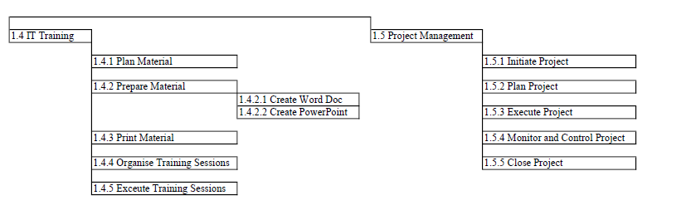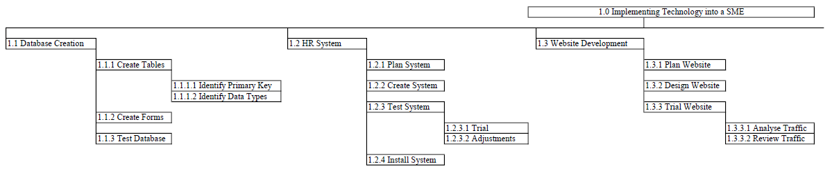

# Project Schedule

## Individual Precedence Lists

|  |  |  |
| --- | --- | --- |
| Project Title: Implementing Technology into a SME | | |
| Shane Kelly | G00391249 | |
| Activity / Task | Duration (Days) | Precedence |
| **Database Creation** | 11 |  |
| Create Tables | 2 |  |
| Identify Primary Key | 1 |  |
| Identify Data Types | 2 |  |
| Create Forms | 4 | 1.1.1 |
| Test Database | 5 | 1.1.2 |
| Database Complete | 0 | 1.1.3 |
|  | | |
| Johan Goh | G00388771 | |
| **IT Training** | 25 |  |
| Plan Material | 2 |  |
| Prepare Material | 3 | 1.4.1 |
| Create Word Document | 3 |  |
| Create PowerPoint | 2 |  |
| Print Material | 1 | 1.4.2 |
| Organise Training Session | 1 | 1.4.2 |
| Execute Training Session | 3 | 1.4.4, 1.4.3 |
| Training Complete | 0 | 1.4.5 |

|  |  |  |
| --- | --- | --- |
| Garreth Mulleady | G00383262 | |
| **Project Management** | 32 |  |
| Initiate Project | 3 | 1.5.1 |
| Plan Project | 7 | 1.5.2 |
| Execute Project | 21 | 1.5.3 |
| Monitor and Control Project | 21 | 1.5.4 |
| Close Project | 1 | 1.5.5 |
| Project Complete | 0 | 1.5.6 |

|  |  |  |
| --- | --- | --- |
| Guan Xian Chua | G00397903 | |
| **Website Development** | 19 |  |
| Plan Website | 2 |  |
| Design Website | 7 | 1.3.1 |
| Trial Website | 10 | 1.3.2 |
| Analyse Traffic | 7 | 1.3.2 |
| Review Website | 3 | 1.3.3.1 |
| Website Complete | 0 | 1.3.3.2,1.3.3 |

## Gantt Chart

The Gantt Chart shows the critical path, which is 32 days long, from 3/1/2022 to 15/2/2022. As all of our deliverables are started concurrently, the critical path follows the project management deliverable, which is set to end seven working days after the last deliverable is complete to allow for slack, such that we can ensure that the project will be completed on time even if there were delays.

The Gantt Chart clearly shows the slack and predecessors of each activity, which allows us to identify the most important activities and how long we are able to delay them before the project must be completed.

## 

## 

## Network (PERT) Diagram

The network diagram shows all the paths that the project can take from start to finish, including the critical path as well as alternative paths. The critical path is the project management deliverable which is highlighted in red. It shows the key activities which need to be done on time for the project to be completed within the time scope. There is no finish slack for the critical path. It also clearly shows precedence activities, such as “Organise Training Session” which cannot be started until “Install System”, “Test Database” and “Prepare Material” are complete.

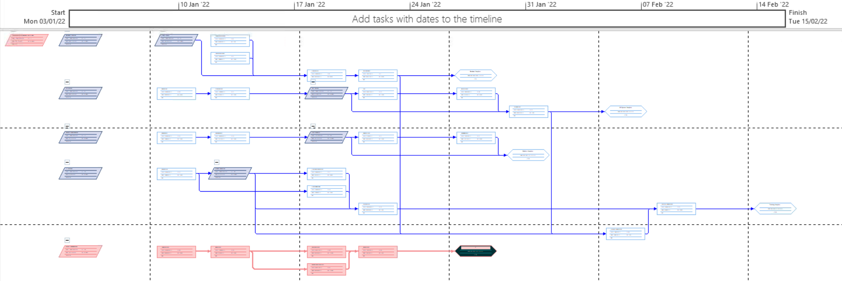

# Budget

## Resource Costs

|  |  |
| --- | --- |
| **Deliverables / Activities** | **Cost** |
| **Database Creation** |  |
| Purchase Database License | 579 |
| Create Table | 450 |
| Create Forms | 650 |
| Test Database | 500 |
|  |  |
| **HR System** |  |
| Plan System | 300 |
| Create System | 700 |
| Test System | 1500 |
| Install System | 250 |
|  |  |
| **Website Development** |  |
| Plan Website | 200 |
| Design Website | 1000 |
| Trial Website | 1500 |
|  |  |
| **IT Training** |  |
| Plan Material | 200 |
| Prepare Material | 300 |
| Print Material | 150 |
| Organise Training Session | 100 |
| Execute Training Session | 300 |
|  |  |
| **Project Management** |  |
| Initiate Project | 300 |
| Plan Project | 700 |
| Execute Project | 1000 |
| Monitor & Control Project | 1000 |
| Close Project | 100 |

## Standard Budget

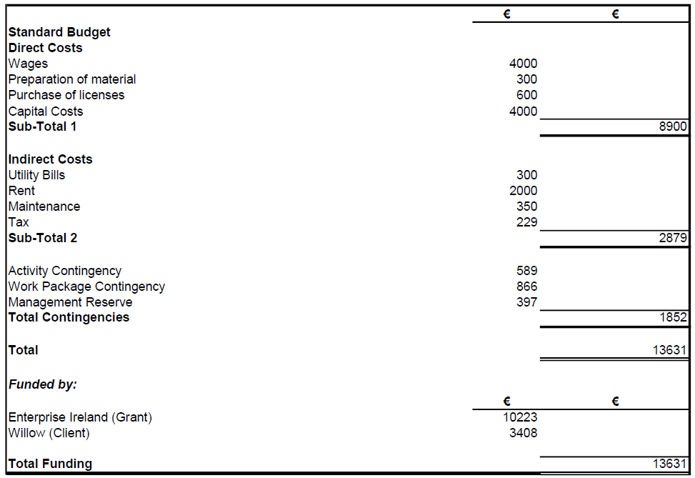

## Project Management Budget

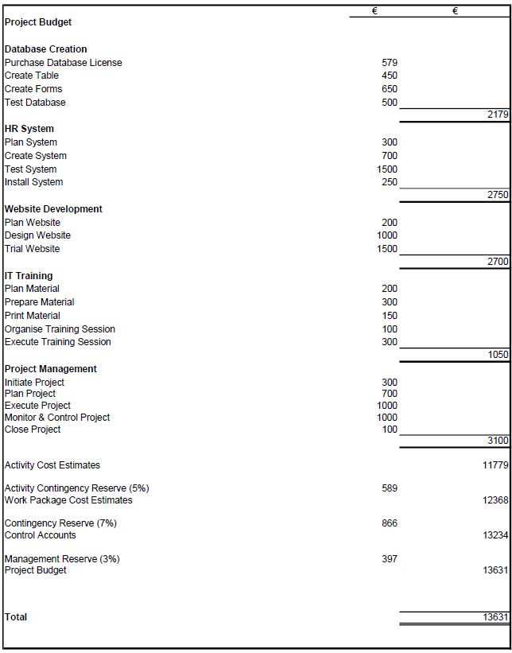

# References

Rowley, S., 2020. *Data Reveals: 5 Reasons Why SME’s Are Struggling to Stay in Business*. [online] Paymentsjournal.com.

Available at: <https://www.paymentsjournal.com/data-reveals-5-reasons-why-smes-are-struggling-to-stay-in-business/>

[Accessed 11 October 2021].

Anon., n.d. *https://www.brightpay.ie.* [Online]

Available at: https://www.brightpay.ie/pricing/

[Accessed 10 11 2021].

CostOwl.com, n.d. *How Much Does a Database Design Service Cost?.* [Online]

Available at: https://www.costowl.com/b2b/design-services-database-cost.html

[Accessed 10 11 2021].

Cushard, B., 2015. *Pricing strategies that maximize sales of software training.* [Online]

Available at: https://blog.learndot.com/pricing-strategies-that-maximize-sales-of-software-training

[Accessed 10 11 2021].

Gregory, A., 2019. *Today's Software Tools Can Help Businesses Become More Efficient.* [Online]

Available at: https://www.thebalancesmb.com/how-to-technology-in-small-business-2951633

[Accessed 10 11 2021].

www.brightpay.ie, N.D. *Simple pricing.* [Online]

Available at: https://www.brightpay.ie/pricing/

[Accessed 10 11 2021].

Z., V. V., 2016. *How much does it cost to build your own human resource management software?.* [Online]

Available at: https://rubygarage.org/blog/how-much-does-it-cost-to-build-hr-software

[Accessed 10 11 2021].

Jason Westland (2015) The Ultimate Glossary of Project Management Terms. [Online] Available from: https://www.projectmanager.com/blog/glossary-of-project management-terms

[Accessed: 02/11/2015]

# Appendix

## Glossary

**Project**

In project management, a project is a short term endeavor performed to develop a unique product, service, or result.

A project is temporary in the sense that it has a specified beginning and end point in time, as well as a defined scope and resources. A project, on the other hand, is defined group of operations meant to achieve a single aim. As a result, a project team, frequently comprises people who do not normally collaborate.

Businesses need people to be able to deliver complex projects on time and on budget. Project include the creation of software to improve a corporate process, the construction of a building or a bridge, or the relief effort following a natural disaster. All of this must be expertly managed by a team of professionals.

**Project Management**

The discipline of initiating, planing, executing, controlling, and concluding the work of a team to achieve defined goals and meet specific success criteria is known as Project Management. It is the application of knowledge, skills, tools, and procedures to project activities in order to fulfil project objectives. The primary constraints are scope, time, and budget. The secondary challenge is to optimize the allocation of required inputs and apply them to accomplish predefined goals.

A project is a one-of-a-kind and temporary undertaking to attain predetermined goals, which can be express in terms of outputs, outcomes, or advantages. A project usually considered a success if it meets the objectives according to the acceptance criteria, within the time frame and budget that was agreed upon.

**Project Manager**

The person responsible for handling every aspect of a project from the day it starts till it closes is called a Project Manager. A project manager’s tasks often include powerful planning, efficient resource usage, and project scope management.

A project manager is someone who acts as a glue and keeps things together. Becoming a project manager is only the starting point of something bigger. At the most basic level, a project manager is held accountable for the project’s success or failure. To keep things on schedule, a project manager must wear numerous hats, sometimes simultaneously. From the start of the project until its completion, he provides on-time delivery and streamlined communication. He’s responsible for steering the team forward and developing a good execution strategy for project goals.

It doesn’t end here. All other critical matters of the project are also all under the radar of a project manager. These issues vary from day-to-day operations to long-term budgets, marketing strategy and schedule management.

**Scope Statement**

A project management plan is critical to ensuring that teams complete their work on time and as expected. Before a project manager can develop an in-depth plan and a project team can execute on that plan, everyone needs to know what work need to be done and why it is important. A project manager must also have a clear understanding of the objectives, timelines, and budgets for each individual project.

That’s where the project scope statement comes into play. A project scope statement is a precise description of the work that must be completed in order to complete a project on time and on budget. The document also situates the project’s goals and output within the larger context of an organization’s aims and objectives. The project scope statement can include: product scope, project scope, list of deliverable, acceptance criteria, project exclusions, limitations, and assumptions.

“You need to understand the structure in which the project will be carried out and consider internal and external factors,” says Jacques Alexis, assistant professor in project management graduate program at Northeastern University’s College of Professional Studies.

**Work Breakdown Structure (WBS)**

A WBS, is “a deliverable-oriented hierarchical decomposition of the work to be executed by the project team to accomplish the project objectives and create the required deliverable. It is a helpful diagram for project managers because it allows them to work backwards from the final deliverable. When used in combination with a Gantt chart that incorporates WBS hierarchies, project management software can be especially effective for planning, scheduling and executing projects.

A work breakdown structure is the first transition of organizational goals into real work. It helps provide clarity of the scope for the project and "breaks down" the scope into whole work units. A deliverable can be delegated to a team or leader who can then be responsible for the work product. The work breakdown structure technique divides projects into smaller more manageable chunks that can be more easily estimated and controlled. When complete, the lowest level components called "work packages" can be delegated to teams for further development and estimating. In this way, project responsibilities can easily be distributed and committed to.

**Critical Path Method (CPM)**

The critical path method is a technique for identifying actions that are required for project completion. In project management, the critical path is the longest sequence of tasks that must be completed to successfully conclude a project, from start to finish. The CPM is used to create project schedules in project management. CPM helps project managers create timeline on a Gantt chart for the project. It uses a network diagram to depict a project and the sequences of tasks required to complete it .

The critical path method includes identifying every task necessary to complete the project and the dependency between them and estimating the time required to complete project tasks. To identify the key activities, calculate the critical path based on the duration and dependencies of the tasks. Concentrating on important activities, planning, scheduling and control also the one of the path of critical path. Lastly, setting project milestones and deliverable and setting stakeholder expectations related to deadlines.

**Slack**

Slack time is a professional term used in project management to help individuals figure out how much time is available between project milestones. It is not about being lazy in project management, despite the fact that the term slack is commonly associated with being lazy and doing nothing. Instead, it tells you how much time you have to start a specific activity in a project in order to keep the project on track. If you exceed the slack time, you will cause the project to be delayed. When certain project tasks take longer than others, slack time is created.

Slack time is a metric that keeps a project on time and within budget. If the project is delayed, then it costs the company more money to finish it. This extra cost can actually prevent the project from being a successful one. With a carefully calculated slack time, everybody working on the project will know just how much time he or she has to finish any particular task.

**Milestone**

A project milestone is a method of observing, measuring, and monitoring a project's progress and/or performance. Milestones are intermediate phases that must be completed before attaining a final goal or objective. In terms of utility, milestones can be specified and serve as a framework for tracking progress. They can also be used to explain and report on the status of a project.

By having milestones, you can make sure that you know if you've completed a quarter of the project or half of it. Then, when the next milestone rolls around you can do the same thing to see if you're on track, behind schedule, or ahead of schedule. If you reach the deadline for a milestone and realize you haven't achieved everything you should have you know that you need to step up a little. With milestones, you don't have to feel so overwhelmed all at the end. You can do a quick and thorough inventory of where you are and where you need to be.

Then, you can make a plan for what you're going to do going forward. Your entire team is going to know how the project is going when you have set milestones.

**Stakeholders**

People or groups who have something to gain (or lose) from the success of your project are referred to as project stakeholders. The Project Management Institute defines project stakeholders as "individuals and organizations who are actively participating in the project”. The term "stakeholder" refers to a person whose interests may be affected positively or negatively as a result of project execution or successful project completion.

As a project manager, it's your job to keep all stakeholders i are, what they do, why they matter, and how to work with them informed, involved, and on-board throughout the project's progression. Stakeholder happiness is one of the key metrics of a successful project, so making sure you get the right buy-in and tick the right boxes — at the right times — is crucial. Here's what you need to know about who they are, what they do, why they matter, and how to work with them. The stakeholders in each particular project will vary depending on the type of project and industry.

**Deliverables**

Deliverables in project management are tangible action items that must be delivered to complete a project. A deliverable is not to be confused with a milestone, which is a specific marker or point in a project when you have achieved something significant. There can be one or several deliverables within a single project, and these interlinked items can be easily mapped using a Gantt chart.

Deliverables in project management can be internal or external. An internal deliverable is work completed within your organization that is not visible to others outside the organization. An external deliverable, on the other hand, is work done for a client, customer, or stakeholder with the goal of generating revenue.

**Gantt Chart**

The Gantt chart is the most widely used chart in project management. These charts are useful in planning a project and defining the sequence of tasks that require completion. The chart shows the project timeline, which includes scheduled and completed work over a period. It aids project managers in communicating project status or plans and also helps ensure the project remains on track.

A Gantt chart is a visualization that helps in scheduling, managing, and monitoring specific tasks and resources in a project. It consists of a list of tasks and bars depicting each task’s progress. Gantt chart are used in heavy industries for projects like building dams, bridges and highways, as well as software development and building out of other goods and services.